Teardrops Falling
Written, performed & co-produced by “Big Joe” Burrell
© 2005 – All rights reserved.

[Instrumental introduction – James Harvey on piano]

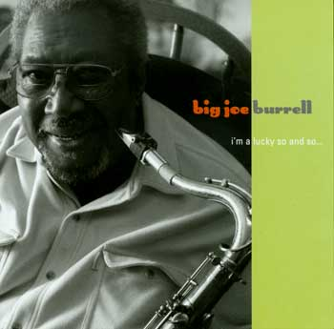
Teardrops falling, baby
Falling down like rain.

Teardrops falling, baby
Falling down like rain.

Won’t somebody help me,
Ease this misery pain?

Hello operator,
Gimme 2-4-6-8-9.

Hello operator,
Gimme 2-4-6-8-9.

Somebody better let me talk to my baby
’Fore I lose my mind.

Some day baby,
I won’t be along…
You’ll long for Big Joe
And he be gone.

Teardrops will be falling,
Falling down like rain.

Won’t somebody help me find my,
Little girl, ease this misery pain?

[James Harvey piano solo] then [BIG JOE’s sax solo]

Some day baby,
It won’t be along…
You come running home,
Big Joe be gone.

Teardrops will be falling,
Falling down like rain.

Teardrops will be falling,
Falling down like rain.

Teardrops will be falling,
Falling down like r-a-i-n.

